DOCKER ENTERPRISE TOOLING

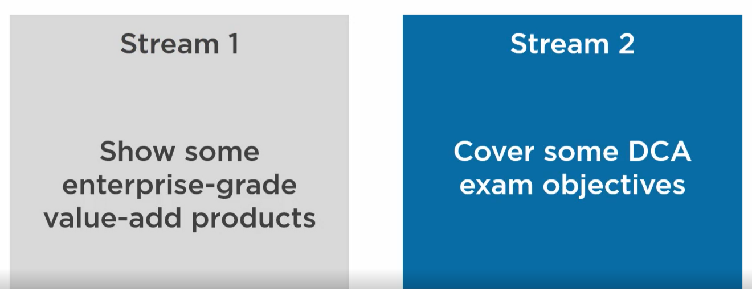

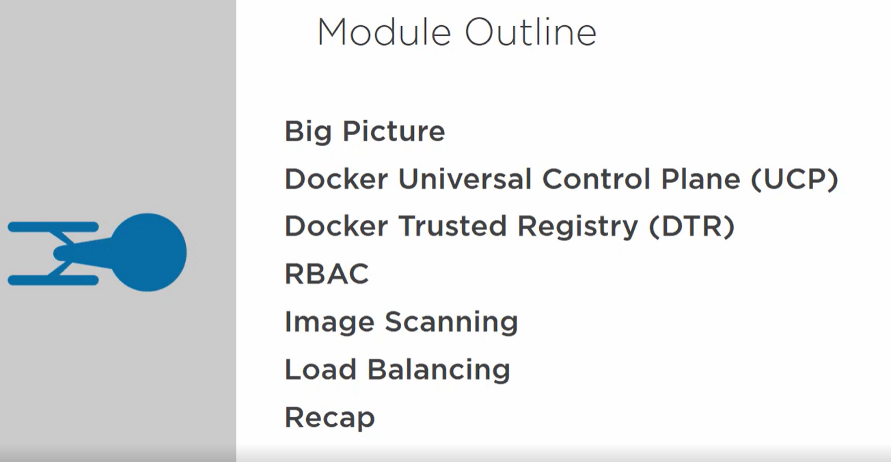

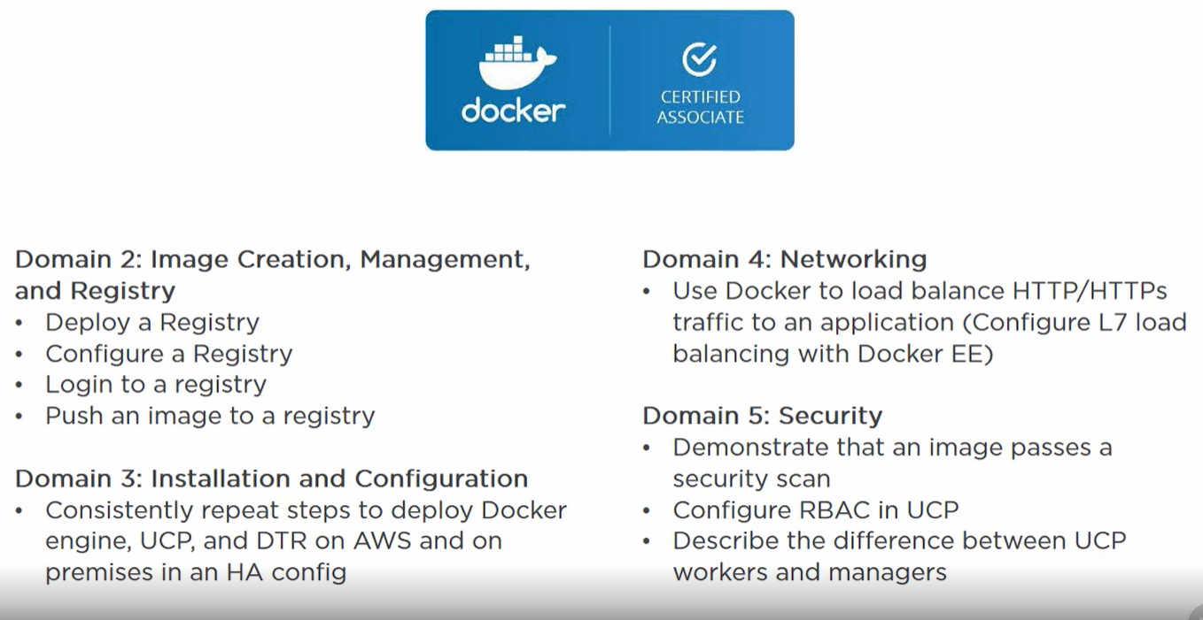



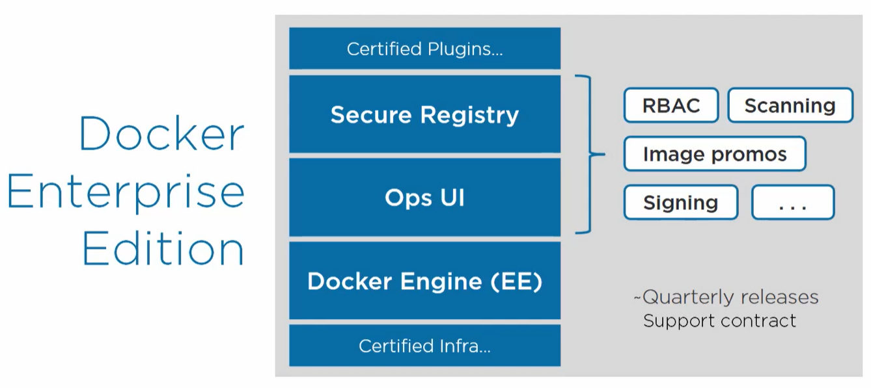

Docker EE has the docker engine **stuff plus** bunch of value addition stuff. Everything is nicely package together.

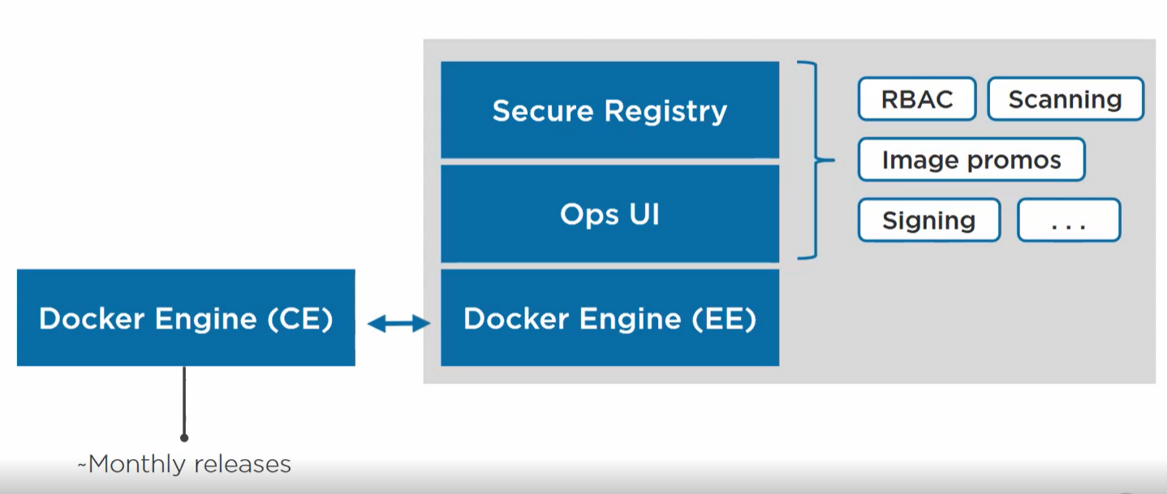

Docker CE has only engine stuff OCI , deamon etc.

At lower level things are similar.



UCP is a GUI to manage swarm and kubernetes apps.

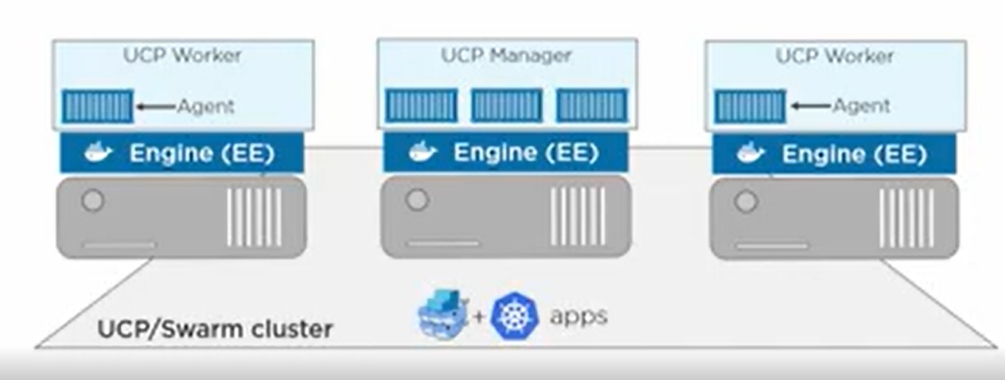

We need a docker EE version first installed in our system.

From docker store page

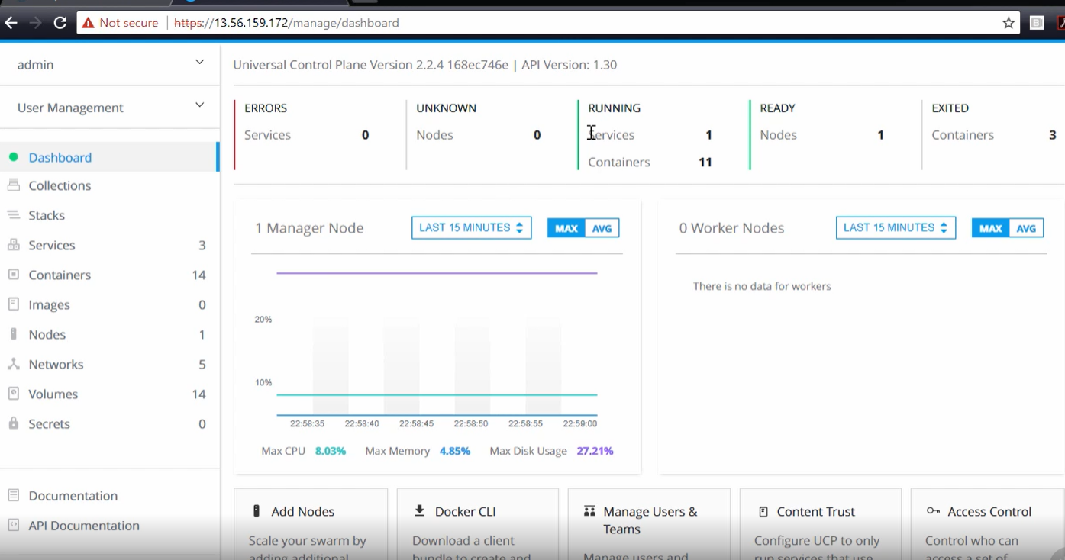



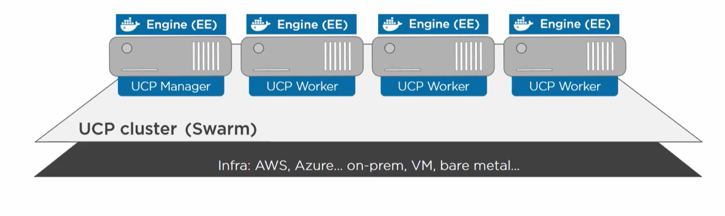

Once we have a swarm cluster we can deploy it anywhere on AWS or on-prem.

DTR is nothing but a private registry running inside our firewall.

DTR will do binary level image scan and look for vulnerabilitites.

**RBAC(Role based access control)**

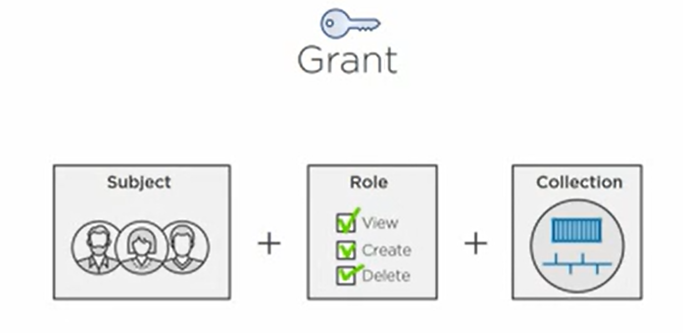

**People will have certain roles to access specific resources.**

**We create subject and teams and provide roles**

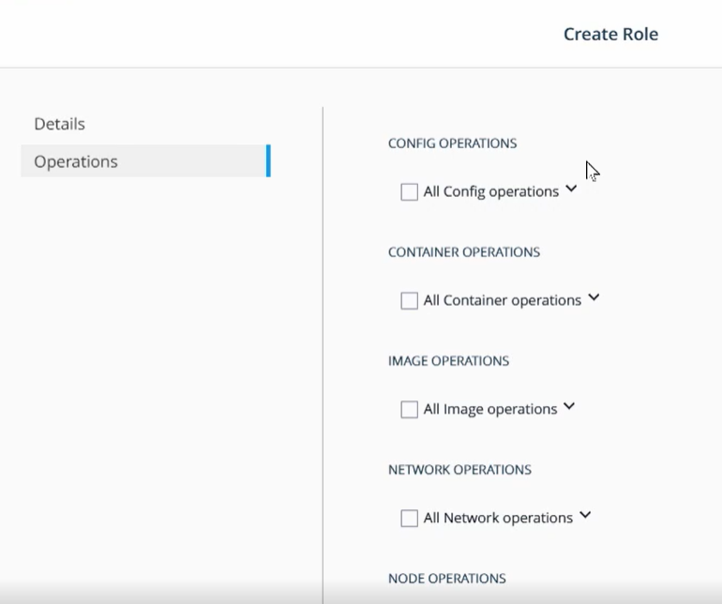

**Image Scanning**

**Before pushing image to registry, we tag it.**

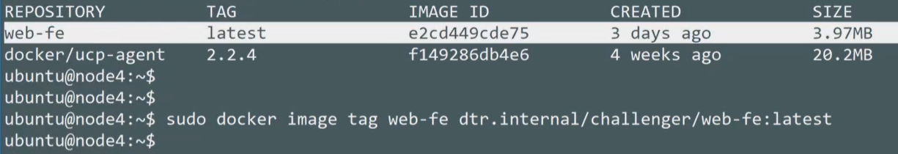

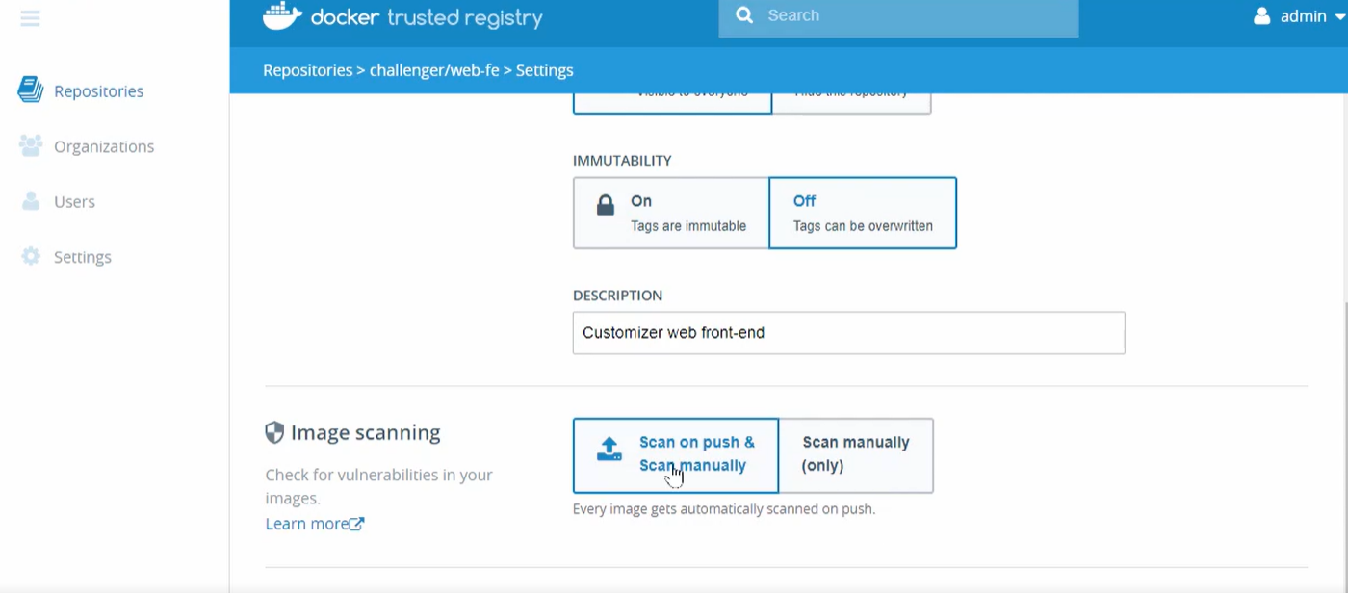

**If we push a dirty image then**

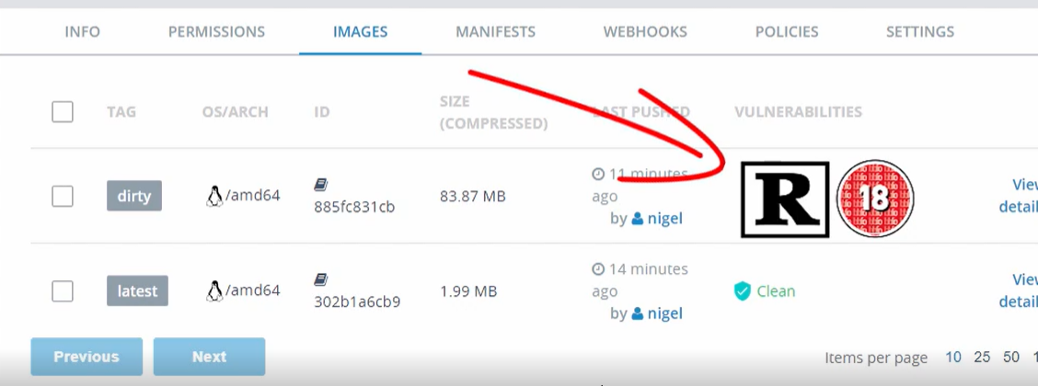

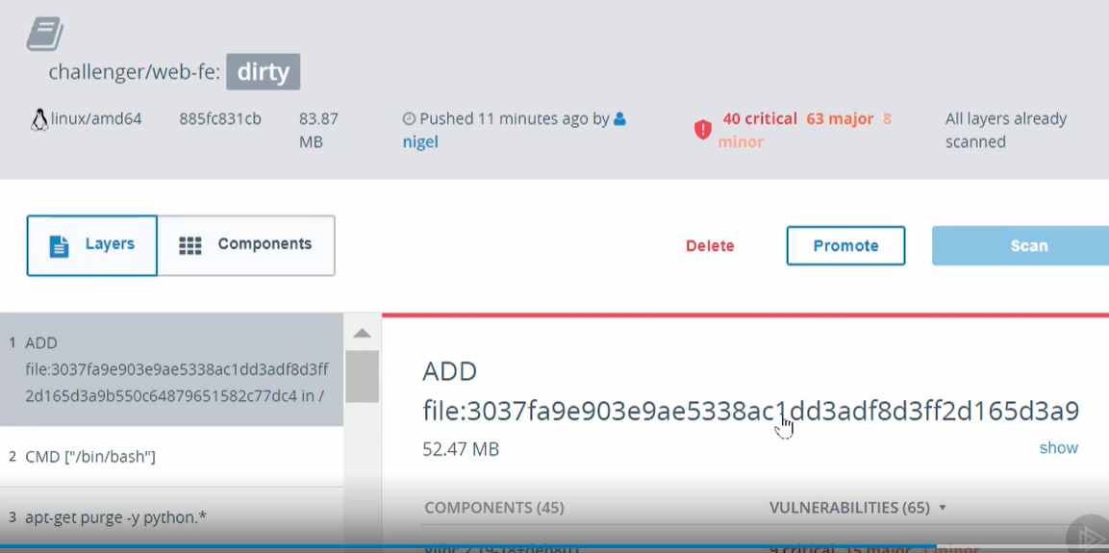

**Layer 7 Load balancing**



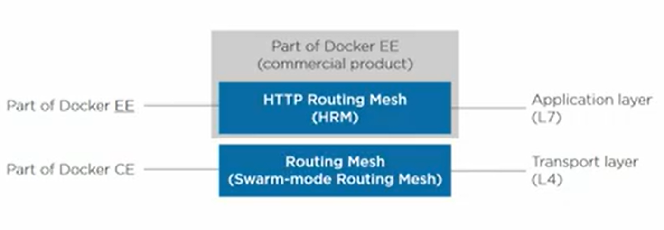

**If we hit any service node we will reach to the desired replica.**

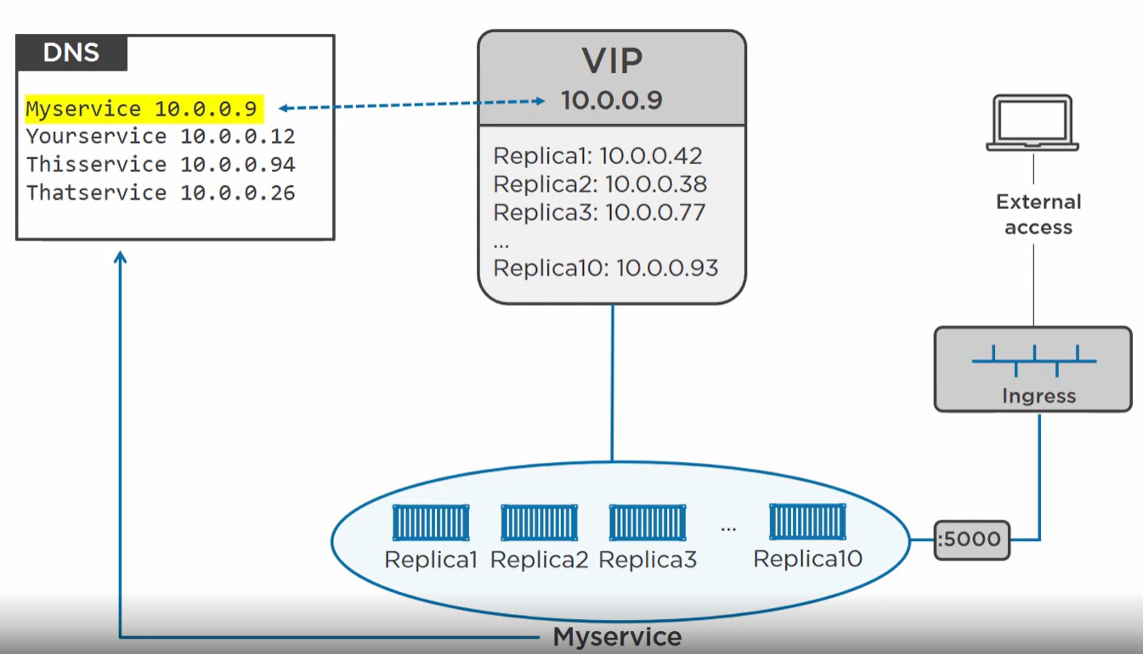

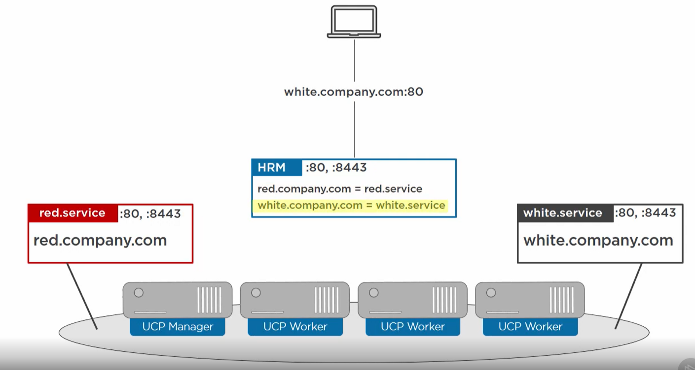

**2 services on a same cluster on the same port and docker knows how to route request.**

